Multiple choice section

|  |  |  |  |  |  |  |  |  |
| --- | --- | --- | --- | --- | --- | --- | --- | --- |
| Question | 1 | 2 | 3 | 4 | 5 | 6 | 7 | 8 |
| Answer | A | D | A | D | A | C | C | D |

Question 1 [6.1]

A

The adjacent side is closest to the angle but not the hypotenuse.

Question 2 [6.1]

D

The hypotenuse is the longest side and is always opposite the right-angle.

Question 3 [6.1]

A

sin(θ) =

Locate the given angle, it is marked θ.

The hypotenuse (opposite the right-angle) is labelled 5 m. The side labelled 2 m is opposite the angle.

The trigonometric function to use is sine.

Question 4 [6.1]

D

tan(θ) =

Locate the given angle, it is marked α.

The hypotenuse (opposite the right-angle) is not labelled. The side labelled 7 cm is opposite the angle. The side labelled 10 cm is adjacent, or next to, the angle.

The trigonometric function to use is tan.

Question 5 [6.2]

A

tan (45°) = 



x = 8

Question 6 [6.2]

C

sin (8) = 

y = 

y = 10.06 m

Question 7 [6.3]

C

Locate the given angle, it is marked θ.

The hypotenuse (opposite the right-angle) is labelled 15. The side labelled 7 is opposite the angle.

The trigonometric function to use is sin.

sin (θ) =

sin (θ) =

θ = sin-1 

θ = 23.578…

θ = 24 (to the nearest degree)

Question 8 [6.5]

D

180 + 30 = 210

Therefore, as a true bearing this is written as 210T.

Multiple-choice total marks: 8

Short answer section

Question 9 4 marks [6.6]

(a)    


(b) θ = cos-1   
θ = 53.13  
θ = 53 (to the nearest degree)

Question 10 4 marks [6.2, 6.3]

(a) tan (67.38) =  
y = 10 × tan (67.38)  
y = 24

(b)   
  
θ = 16 (to the nearest degree)

Question 11 2 marks [6.4]

Identify the trig ratio for which you have the required information.

From the angle of 63, you have the opposite side at 85 cm and the hypotenuse is labelled x. The correct ratio is sine.

sin (63) = 

x = 

x = 95.397…

x = 95 cm

Question 12 2 marks [6.4]

Identify the trig ratio for which you have the required information. From the angle of 23, remember that this is the same as the angle at bottom left of the triangle.

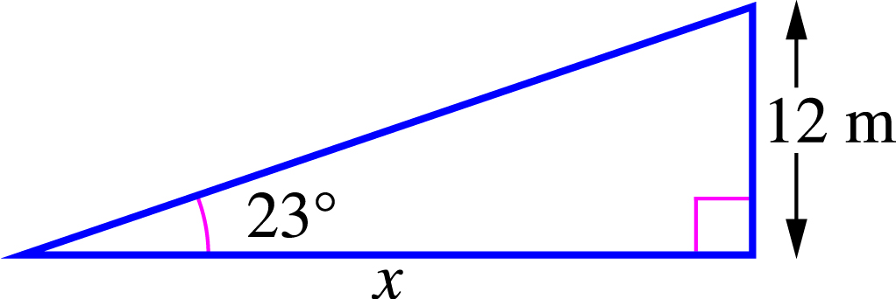

You have the opposite side at 12 m and the adjacent side is labelled x. The correct ratio is tan.

tan (23) = 

x = 

x = 28.270…

x = 28.3 m

Question 13 2 marks [6.5]

(a) Subtract 30 from 90 to find the angle from north to the bearing.  
90 - 30 = 60  
Use this to describe the bearing from north to west: N60°W

(b) To write the true bearing, add all of the degrees to the bearing line, or subtract 60 from 360.   
360 − 60 = 300°  
Use this to write the true bearing: 300°T

Question 14 4 marks [6.5]

(a) tan (42) =    
x = 15 × tan (42)   
x = 13.506…  
x = 13.5 km (1 d.p.)

(b) cos (42) =    
y =    
y = 20.184…  
y = 20.2 km

Question 15 7 marks [6.6]

(a) Let h be the height of the wall.  
  
The height is 150 cm.

(b) Let d be the distance from the foot of the ladder to the top of the wall.  
  
The ladder overhangs by:   
4 – 3.087 = 0.912 m  
 = 91 cm

(c) Let t be the height of the tree.  
  
The height of the tree is 194 cm  
194 – 150 = 44 cm   
It is 44 cm more than the height of the wall.

Short answer total marks: 25

Extended response section

Question 16 5 marks [6.6]

(a)

  
The angle is 24 (nearest whole number)

(b)   
  
Extra distance dived: 7.86 – 5.3 = 2.56 m

Question 17 6 marks [6.6]

(a) Let x be the length of cable plus the height of container.  
  
Length of cable is:  
13.75 + 1.2 – 2 = 12.95 m

(b) The horizontal distance of the crane from the container before it moves is .  
The new distance of the crane from the container is 12.38 – 4 = 8.38 m.  
Let θ be the required angle.  


Extended answer total marks: 11

TOTAL test marks: 44